**OPENFABRIC TESTNET BUG REPORT**

1. The QR code’s purpose is not mentioned.

Bug: The time restarts after every 10 minutes. Scanning the QR code gives a “Status 404 Not found” error.

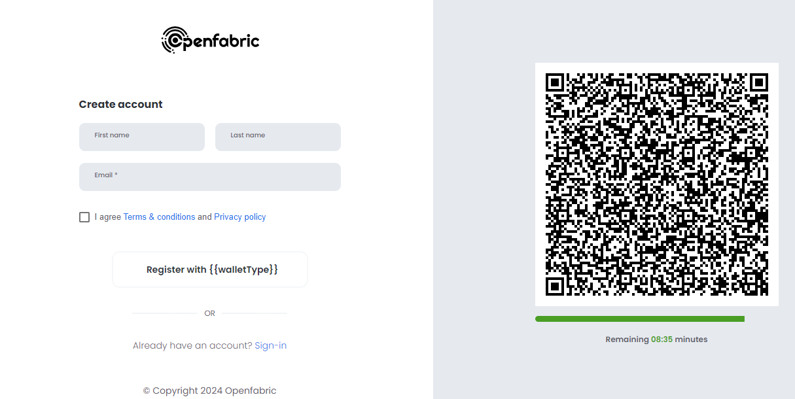

1. If the mouse points to each icon, it does not display what these are.

(From the main page of Openfabric https://openfabric.ai/)

